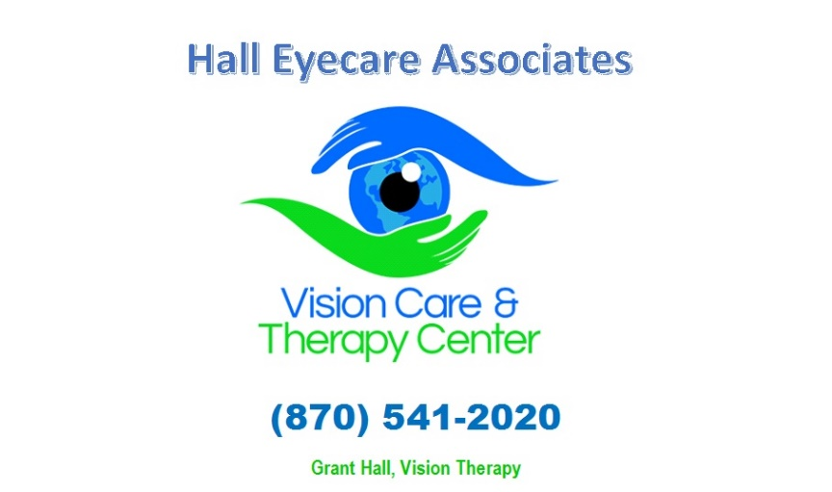
WHAT IS OPTOMETRIC VISION THERAPY?

Optometric vision therapy is an individualized treatment program designed to improve overall visual function and performance. Its proven results are derived from vision-based neurological and neuromuscular conditioning over time. When provided by a knowledgeable optometrist, vision therapy results in quantitative improvements in visual and visual information processing skills and, perhaps more importantly, an improvement in quality-of-life due to decreased symptoms and improved performance.

Many functional vision problems can be significantly improved through optometric vision therapy. It is a treatment modality for disorders including, but not limited to:

• Ocular motility dysfunction – eye movement disorders
• Vergence dysfunction – inefficiency in using both eyes together
• Strabismus – misalignment of the eyes
• Amblyopia – lazy eye
• Accommodative disorders – focusing problems
• Visual information processing disorders
• Visual sensory and motor integration
• Visual rehabilitation after traumatic brain injury which results in inefficient visual information processing (e.g., stroke)

These visual conditions are best treated with optometric vision therapy, which enables an individual to learn more efficient ways to perform visually. Optometric vision therapy can improve visual function much like physical therapy can improve general motor function.

Optometric vision therapy, also referred to as visual training or orthoptics is an established, medically necessary therapy when prescribed by an optometrist. Clinical tests with associated normative values are administered to determine the presence of visual deficiencies. If optometric vision therapy is indicated, the optometrist recommends a specific treatment plan for the individual.

Optometric vision therapy plans typically involve a programmed combination of office treatment and home therapy. Lenses, prisms, optical instruments, and specially adapted computers are some of the devices through which one learns to use vision more effectively. The specific materials are less important than the feedback provided to the patient to enable change. Visual skills need to be developed until they become automatic and integrated with other visual as well as cognitive skills. As with most therapeutic treatments, the extent of success is also linked to patient compliance.

The principal benefits of optometric vision therapy, which include improved visual information processing and the ability to sustain visual function over time, are as applicable to the child in the classroom as they are to the adult using a computer or reading a book.

Without efficient visual skills the act of reading can be very frustrating. To the child with learning-related vision problems – often called a “hidden disability” – these frustrations can spill over into behaviors that can present themselves in a fashion similar to ADD/ADHD or dyslexia.

According to the American Optometric Association, 35-40% of all children with learning disabilities have visual problems. Specifically, at least 20% of individuals with learning disabilities have been found to have prominent visual information processing problems, and 15-20% of them have problems with visual efficiency skills.

Some of the common symptoms relieved through vision therapy include eye strain, visually induced headaches, inability to concentrate when doing visual tasks, and errors such as loss of place or reversals when reading or writing. More often, individuals have no recognized symptoms due to their avoidance of visually demanding tasks or an adaptation that decreases their performance. Optometric vision therapy also facilitates appropriate visual development, and serves as a component of the multi-disciplinary effort following stroke or head injury.

